Goals for what project should include:
- Some sort of R and D, would be great to have a model/product
  - Since it is self sponsored, product must not be too expensive
- Some sort of coding and/or Simulation: Python, Matlab, CFD

Promising Idea 1: Optimizing solar thermal collector design

Main Idea: Design an affordable solar thermal collector system to maximize heat absorption that is integrated with the hot water line to decrease the amount of energy/carbon emissions from heating household water.

Steps/components of the project:
- Research existing products, materials, and piping diagrams
- Write a matlab/python program that calculates the theoretical heat absorption based on the shape and material we choose
- Based on best material/shape combination (Heavily influenced by cost), plan and build prototype
  - Includes the valves and water circuit planning
  - Make pump controller → Tells when to turn pump on and off
    - May be as simple as is it day or night
    - Would like to add more complexity to save energy if possible
  - Decide if integrate with another water heater or just have storage tank for the warmed water
    - Consider water mixer and temperature of intake cold domestic water
- Calculate the savings in different locations around the United States based on weather data
  - Would this depend on humidity too?
- Create a model of the water and heat flow throughout the system
  - Use data from thermometers/flow meters to provide the user with exact savings

Already existing products:
- 30 tube from amazon (> $1000)
- 15 tube from HydroSolar ($746)
- DIY Flat solar collector ($60)
- DIY Spiral tube collector ($400 including lumber for building frame)

Pros:
- Opportunity to work with pump/water loop
- Opportunity to include sensors and possibly microcontroller/code
- Interesting heat transfer application

Cons:
- This could be pretty expensive. (Probably somewhere in the 500+ dollar range?)
Actual product:
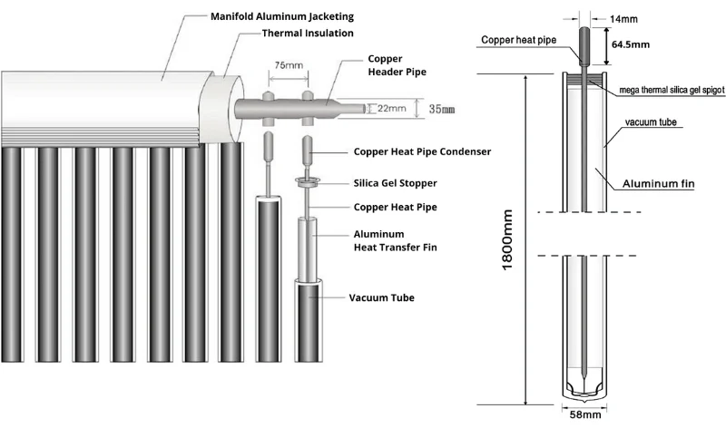
DIY:

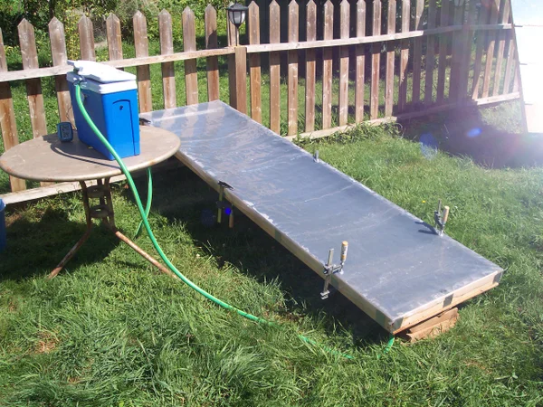

Promising Idea 2: Use cold reservoir and smart controller to make smart refrigerator (Idea from a past senior project)

Less than 100 words:
We propose to create a small refrigerator with a local cold-reservoir and smart controller which knows when to switch between active and passive refrigeration based on time of use utility rates. The purpose of the refrigerator is to save the user money and decrease carbon emissions. This project would provide a great opportunity to work with mechanical design in the design of the refrigerator itself, mechatronics as there will be many sensors, data analysis, and a microcontroller, electronics as there must be several fans and refrigeration components, as well as thermal design working with the refrigeration loop and insulation.

will involve the mechanical design of the refrigerator itself, the use of sensors and a microcontroller, electronics to control fans/refrigeration components, and consideration of the

Main Idea:

Steps/components of the project:
- Perform calculations (matlab or python script) to calculate current heat loss
  - Must consider door opening/closing, capacity of the fridge, and intake temperature
- Determine best option for cold-reservoir (probably ice or really cold water?)
- Research and prototyping of refrigerant loop, refrigerator design
  - We could start with an existing mini-fridge shell or make our own refrigerator from scratch
  - Must consider how to insulate the cold reservoir when not in use
  - Research how to safely work with refrigerant
- Code/develop smart controller to operate based on utility rates
  - Could include sensors to determine opening and closing as well as intake temperature and take that into account

Pros:
- Great opportunity to include mechatronics concepts (sensors, microcontroller, coding)
- Opportunity for the mechanical design of the refrigerator itself (Can do ME 154 force and stress calculations)
- It’d be so awesome to work with a refrigerant loop
Cons:
- May be expensive (Maybe less expensive than solar collector)
- Refrigerant can be dangerous (have to be careful choosing refrigerant and ensuring no leaks)

1/27/25
Isabel Price and Kalino Ruiz

Smart Refrigerator Initial Proposal

Main Idea: We propose to create a small refrigerator with a local cold-reservoir (ice storage) and smart controller which knows when to switch between active and passive refrigeration based on time of use utility rates. Essentially, the refrigerator will use its refrigeration system to make extra ice during the night and then turn off the refrigeration cycle and instead use a small fan to blow air over the ice during the day.

Purpose: The purpose of the refrigerator is to save the user money by decreasing power usage during time periods with high utility rates. Additionally, the refrigerator should be as efficient as possible to decrease carbon emissions.

Why this is such a great project:
- Great opportunity to include mechatronics concepts (sensors, microcontroller, coding)
- Opportunity for the mechanical design of the refrigerator itself (Can do ME 154 force and stress calculations)
- Involves thermodynamics and heat transfer concepts in the refrigeration cycle and insulation
- The outcome is the development of a physical product. This allows us to analyze the performance and quantify our success

Steps/components of the project (Not necessarily in consecutive order)
- Research existing technology:
  - Current refrigerator designs
  - Refrigerator insulation materials
  - High efficiency refrigerators
  - Types of refrigerant
- Create CAD model of refrigerator design
- Perform calculations using Matlab or Python script to calculate:
  - Heat transfer in all parts of the refrigerator
  - Force and stress of fridge door (hinges)
  - Power requirements
- Design refrigeration cycle and choose proper components (compressor, fans, etc)
  - Must consider that the cold reservoir ice will melt into water that must be collected and refrozen
- Implement sensors, circuitry, microcontroller, and code to monitor temperatures and control the passive/active modes
- Using the sensors, analyze the performance of the refrigerator to determine the success of our design

The Sponsored Thermal Project - Good option as well

Project 8: (sponsored by Dr. Keith Yi)
Electronics cooling design
Electronic equipment often generates significant heat that needs to be dissipated to the environment via various processes, i.e. conduction, convection and/or radiation. In this project, we’d like to evaluate/compare the heat transfer methods: conduction, natural convection, forced convection and radiation, utilizing some heat transfer devices such as extruded fins, heat pipes, wedge-locks, or different housing materials (aluminum, steel, etc). Analytical/numerical solutions are sought first to determine the testing configuration (to show adequate differences between different methods). An actual thermal testing will be performed to collect temperatures at various locations and compare with predictions.
Review/understanding of the basic thermocouple theory, correlation equations for natural and forced convections, radiation parameters (emissivity, etc) and heat pipe/ wedge lock operations are needed as part of the project.
A full report in Word and a summary presentation are required. The final presentation will be done at the end of ME 195 B.

Other thoughts (Not developed):

Design of a passive cooling system for a building:
Main Idea: Explore the use of natural ventilation, shading, and other passive cooling techniques to reduce cooling load.

Waste Heat Recovery:
Design a system to recover waste heat from industrial processes and utilize it for heating or power generation.
Analyze the thermodynamic feasibility of using a heat exchanger to recover heat from exhaust gases.

